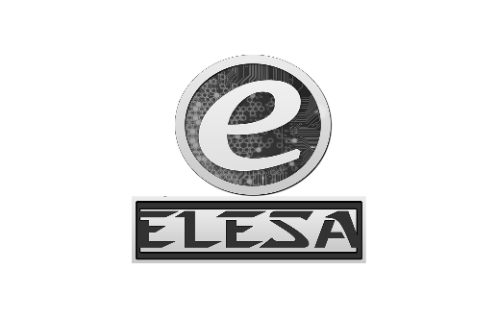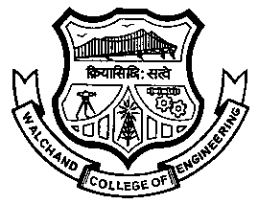WALCHAND COLLEGE OF ENGINEERING, SANGLI

**ELESA**

**ELECTRONICS ENGINEERING STUDENTS’ ASSOCIATION**

DATE:

To,

_________________

_________________

_________________

**SUBJECT:** Permission for campaigning of the mega-event **“ELECTROVERT”** of Electronics Department of WCE, Sangli in your college.

Respected Sir/Madam,

On 17th and 18th September 2016, Electronics Engineering Students’ Association of Walchand College of Engineering, Sangli is organizing a two day technical mega event **‘ELECTROVERT’** in our college.

**ELECTROVERT** comprises of many different engineering fields. It will surely help the students in not only developing their technical skills, but also in dynamically shaping their personalities.

So, please grant us the permission for the campaigning of our event in your prestigious college. For campaigning we would be requiring a counter, displaying our poster on notice board and announcements in the classrooms. We assure you that this event will surely be helpful for your students.

Also, we assure you that our presence in your campus will not cause any hindrance to academic works of your college.

Thanking You...

Yours faithfully,

**HOD,**

**Dept. Of Electronics**

Dr. B. G. Patil

**Staff Advisor**

Dr. S. D. Ruikar

**President**

Amol Gaykhe

*president@elesa.in*

**Vice-President**

Pavan Chopade

*vicepresident@elesa.in*

**Event Director**

Rukkaiyya Shekh

*event@elesa.in*

**Technical Director**

Vidya Mane

*technical@elesa.in*

**Club Service Director**

Tejashree Chougule

Saraswati Solage

*csd@elesa.in*

**Web Developer**

Narsing Mundhe

*pro@elesa.in*

**Treasurer**

Samrudddhi Kulkarni

*treasurer@elesa.in*

**Aptitude Developer**

Tejashree Chougule

Saraswati Solage

*aptitude@elesa.in*

Mr. Amol Gaykhe,

President, ELESA